**NAME: Vishal Shashikant Salvi**

**UID: 2019230069**

**BATCH: C**

CEL 51, DCCN, Monsoon 2020

Lab 4: Prototyping a Network

**Objective:**

Prototype a network using Packet Tracer

**Background**

A client has requested that you set up a simple network with two PCs connected to a switch. Verify that the hardware, along with the given configurations, meet the requirements of the client.

**Step 1: Set up the network topology**

1. Add two PCs and a Cisco 2950T switch
2. Using straight-through cables, connect **PC0** to interface **Fa0/1** on **Switch0** and **PC1** to interface **Fa0/2** on **Switch0**.
3. Configure PC0 using the **Config** tab in the PC0 configuration window:
   1. IP address: 192.168.10.10
   2. Subnet Mask 255.255.255.0
4. Configure PC1 using the **Config** tab in the PC1 configuration window
   1. IP address: 192.168.10.11
   2. Subnet Mask 255.255.255.0

**Step 2: Test connectivity from PC0 to PC1**

1. Use the **ping** command to test connectivity.
   1. Click PC0.
   2. Choose the **Desktop** tab.
   3. Choose **Command Prompt**.
   4. Type: **ping 192.168.10.11** and press *enter*.
2. A successful **ping** indicates the network was configured correctly and the prototype validates the hardware and software configurations. A successful ping should resemble the below output:
3. Close the configuration window.
4. Click the **Check Results** button at the bottom of the instruction window to check your work..

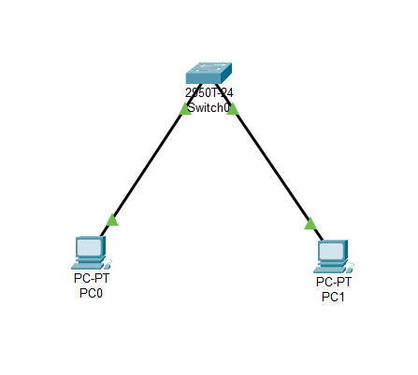

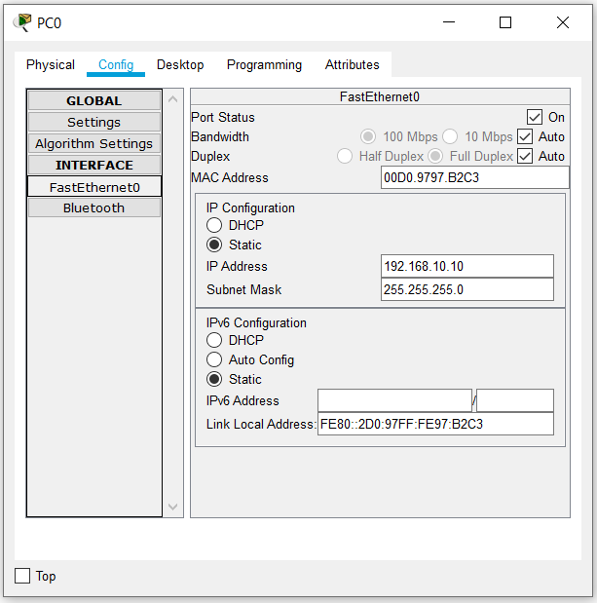

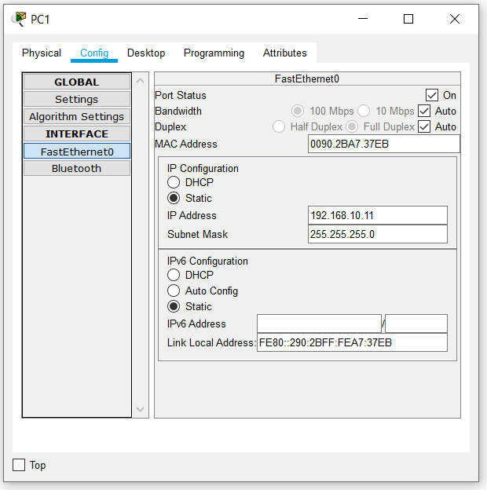

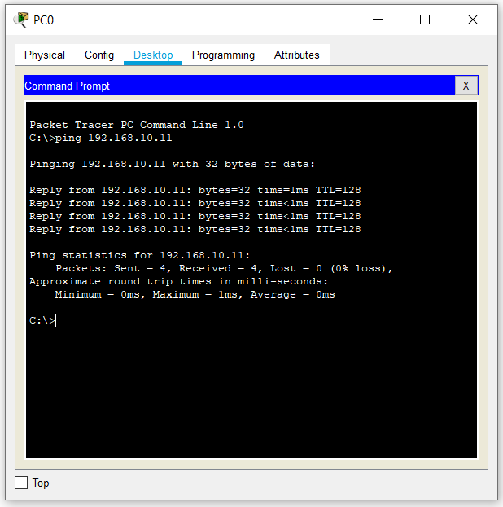

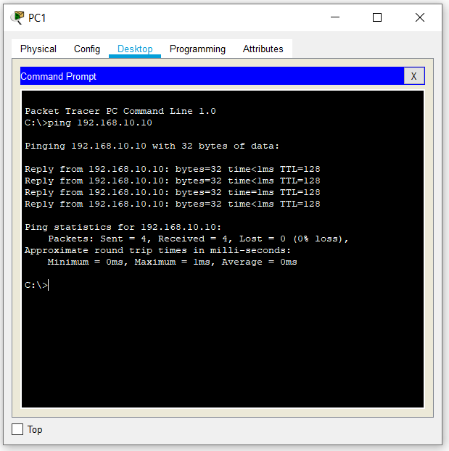

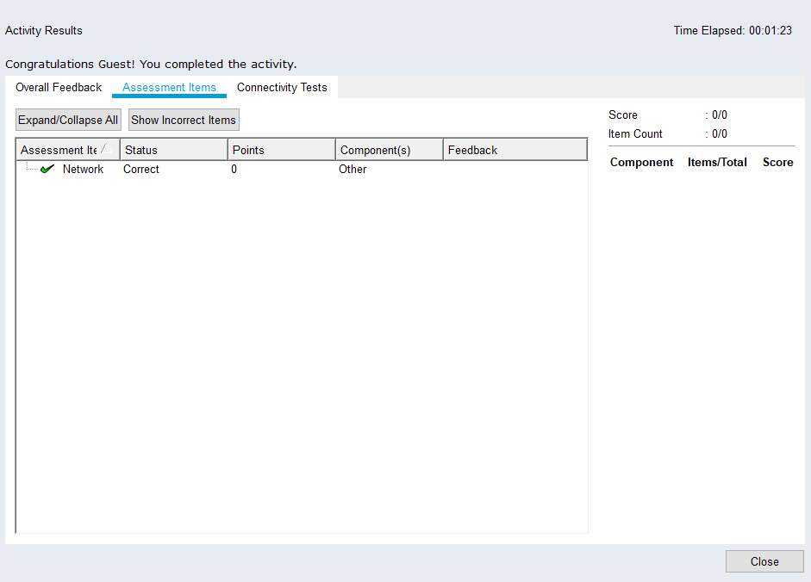

CEL51, DCCN, Monsoon 2020

Lab 4.1: Basic configuration - hostname, motd banner, passwd etc

**Objective:**

This lab will test your ability to configure basic settings such as hostname, motd banner, encrypted passwords, and terminal options on a Packet Tracer 6.2 simulated Cisco Catalyst switch.

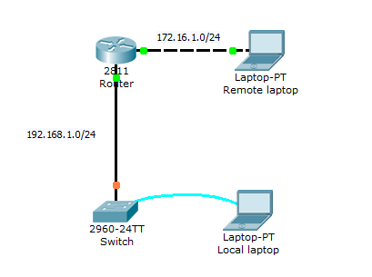

1. Use the local laptop connect to the switch console.  
  
2. Configure Switch hostname as LOCAL-SWITCH  
  
3. Configure the message of the day as "Unauthorized access is forbidden"  
  
4. Configure the password for privileged mode access as "cisco". The password must be md5 encrypted  
  
5. Configure password encryption on the switch using the global configuration command  
  
6. Configure CONSOLE access with the following settings :  
- Login enabled  
- Password : whatever you like  
- History size : 15 commands  
- Timeout : 6'45''  
- Synchronous logging   
  
6. Configure TELNET access with the following settings :  
- Login enabled  
- Password : whatever you like  
- History size : 15 commands  
- Timeout : 8'20''  
- Synchronous logging   
  
7. Configure the IP address of the switch as 192.168.1.2/24 and it's default gateway IP (192.168.1.1).  
  
8. Test telnet connectivity from the Remote Laptop using the telnet client.

**Use the local laptop connect to the switch console.**

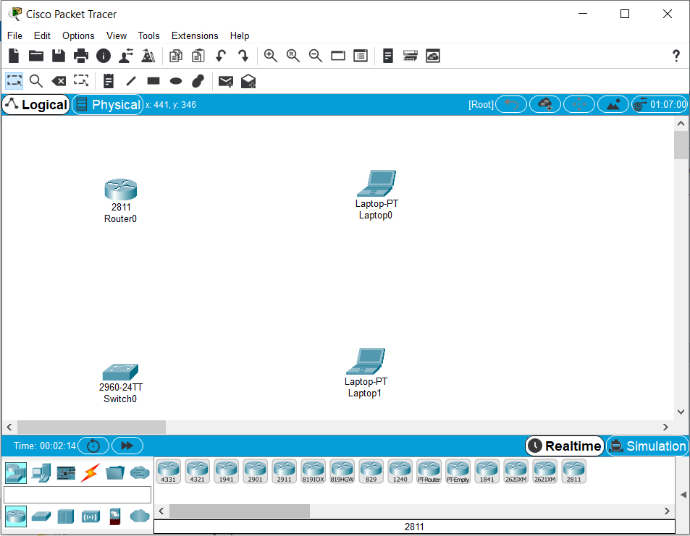

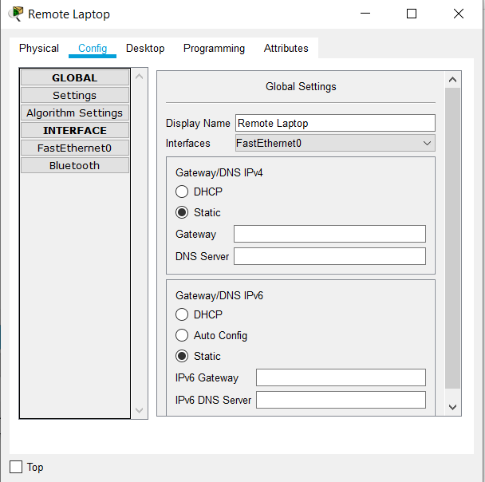

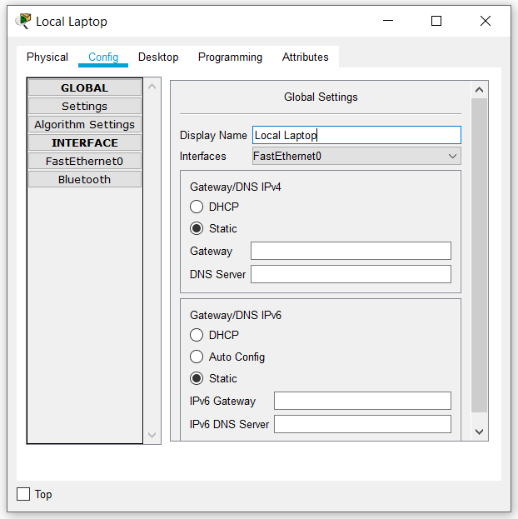

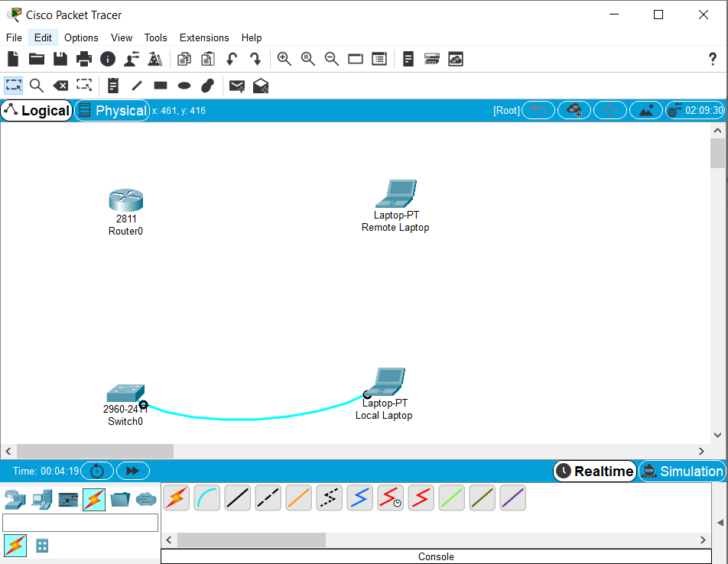

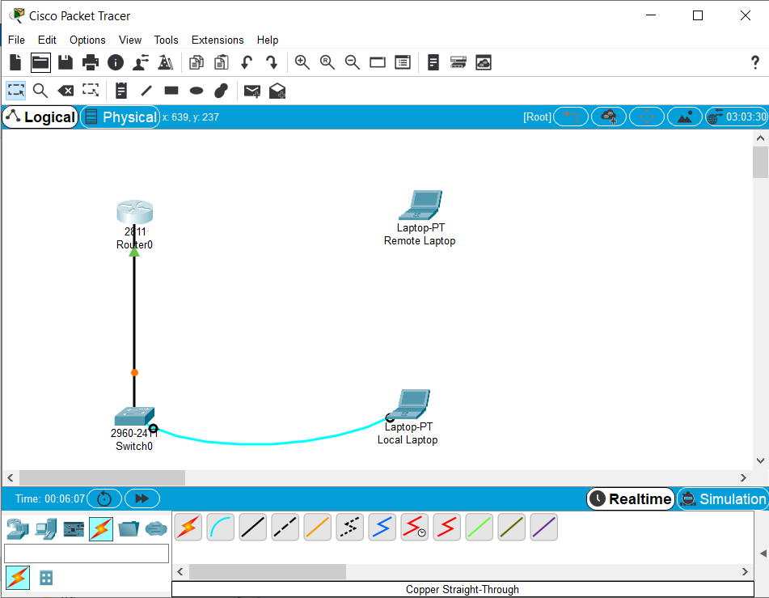

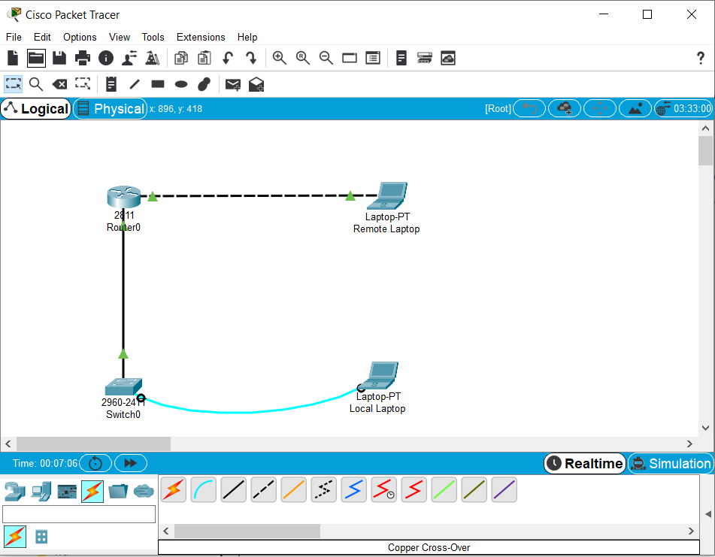

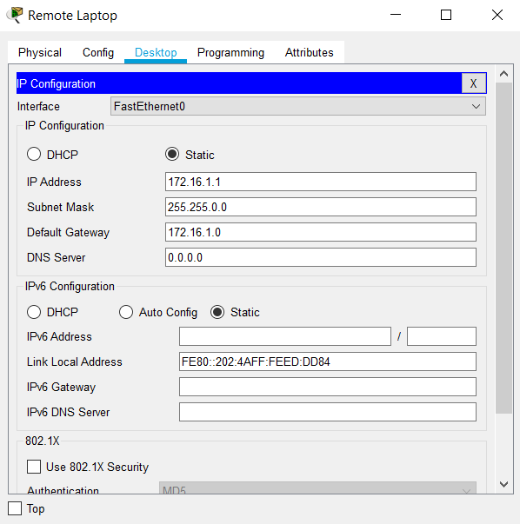

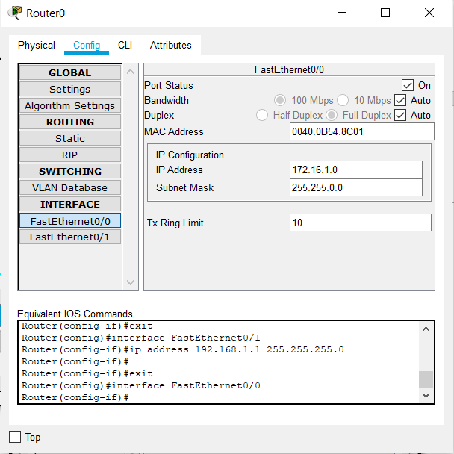

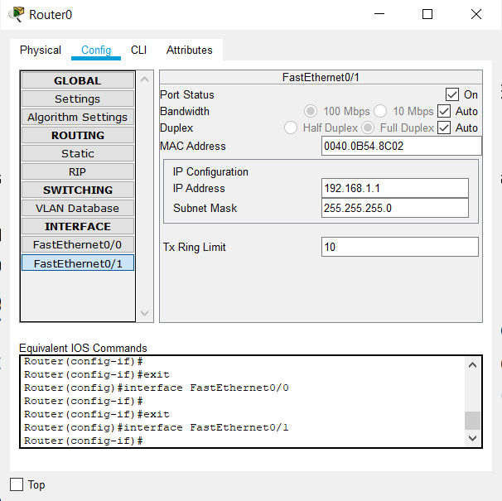

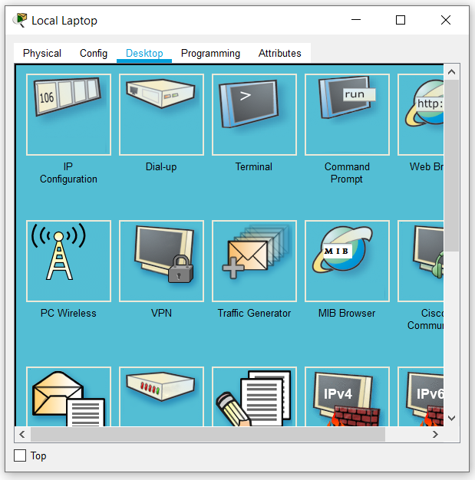

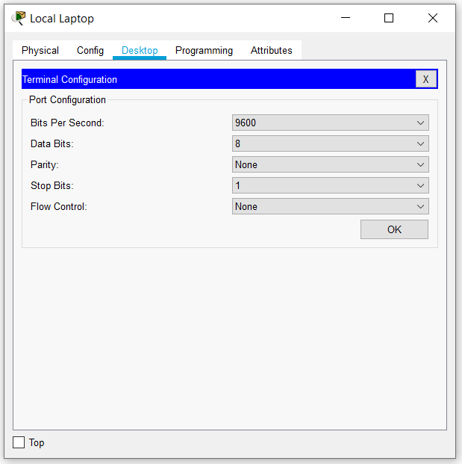

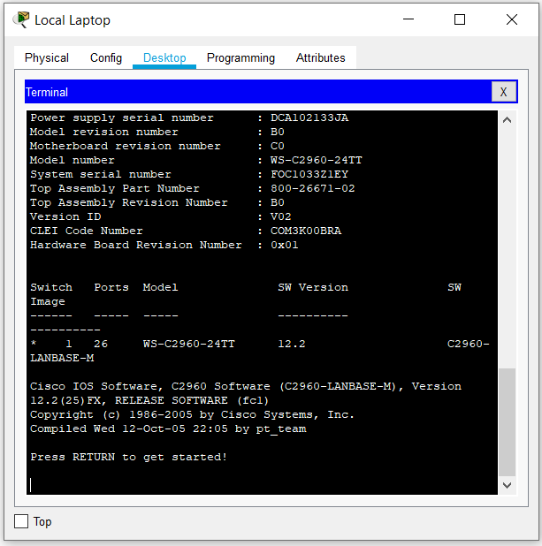

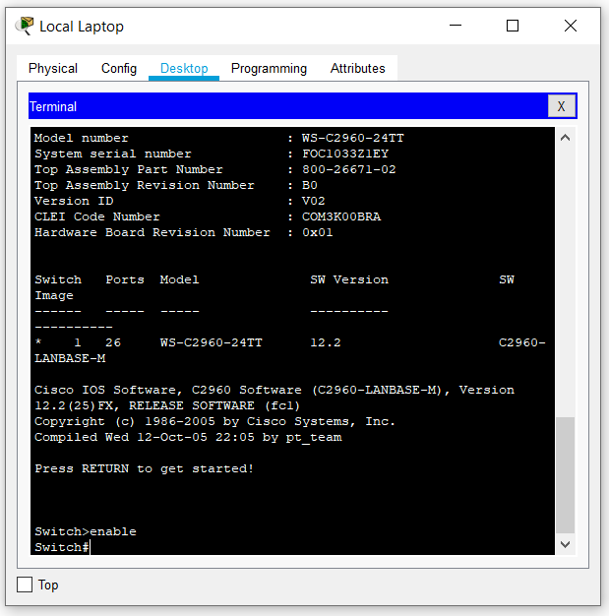

**Configure Switch hostname as LOCAL-SWITCH**

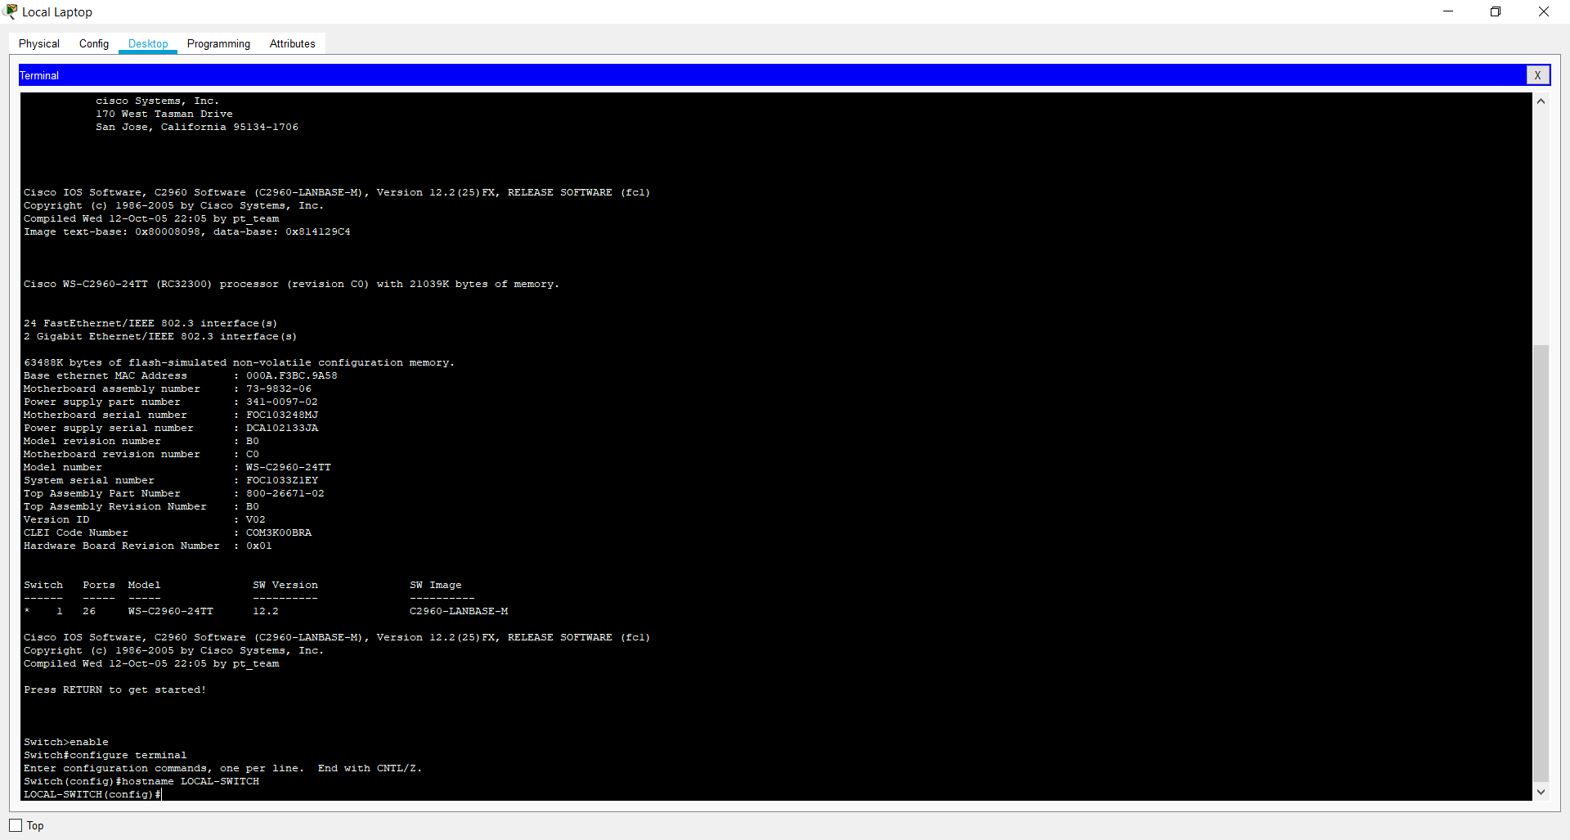

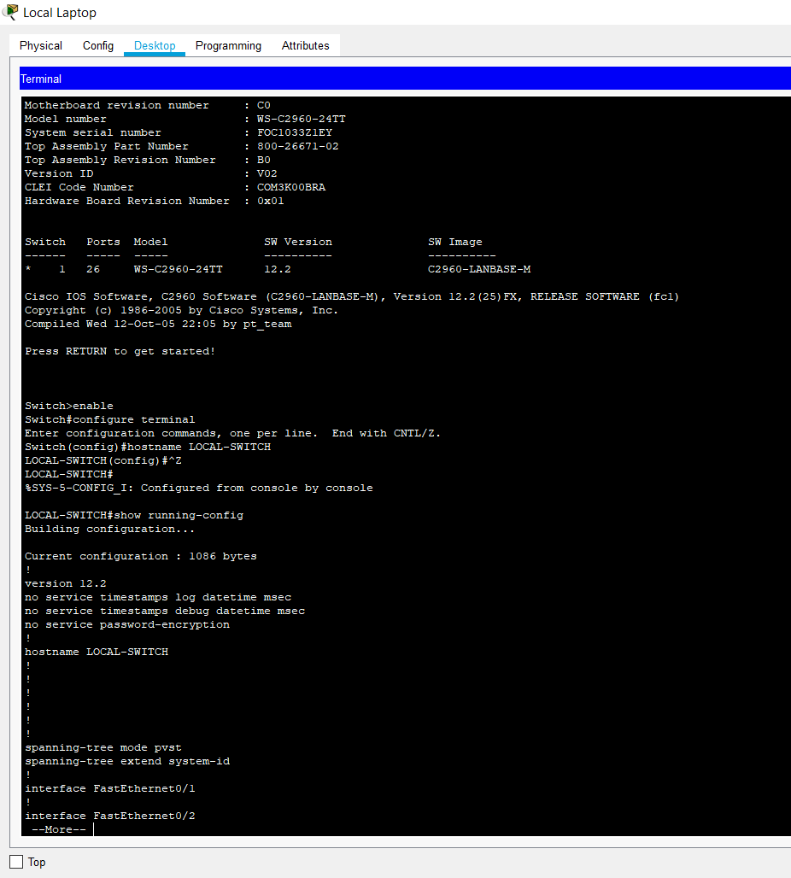

**Configure the message of the day as "Unauthorized access is forbidden"**

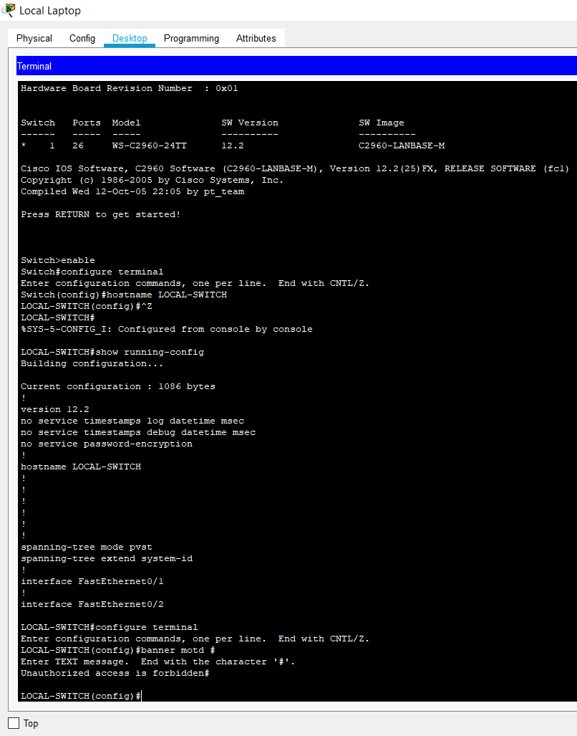

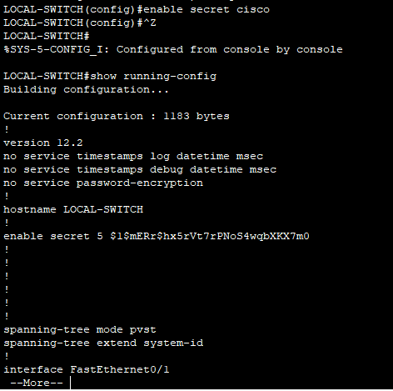

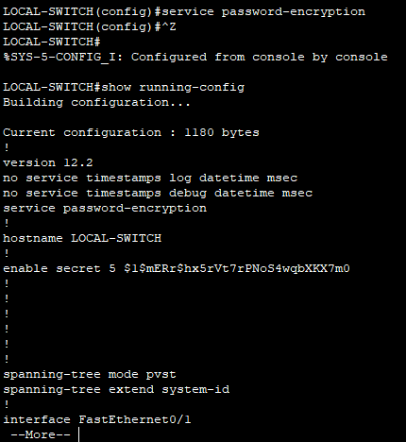

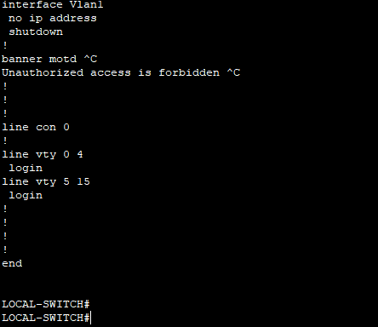

**Configure CONSOLE access with the following settings :  
- Login enabled  
- Password : whatever you like  
- History size : 15 commands  
- Timeout : 6'45''  
- Synchronous logging**

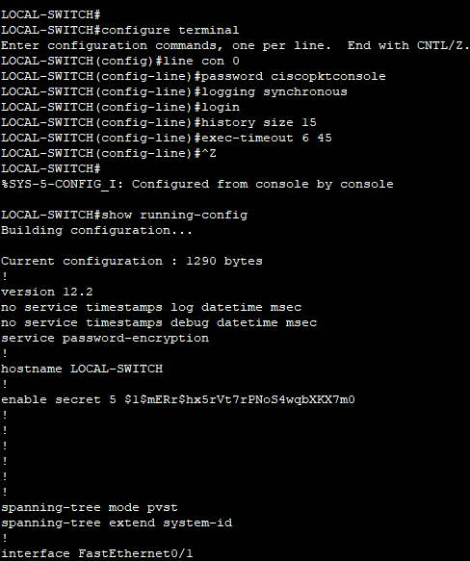

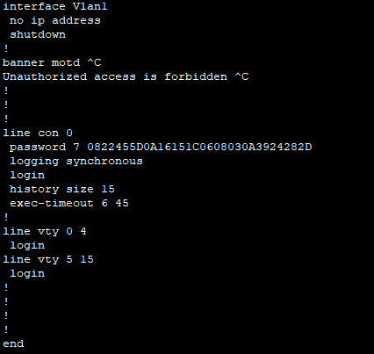

**Configure TELNET access with the following settings :  
- Login enabled  
- Password : whatever you like  
- History size : 15 commands  
- Timeout : 8'20''  
- Synchronous logging**

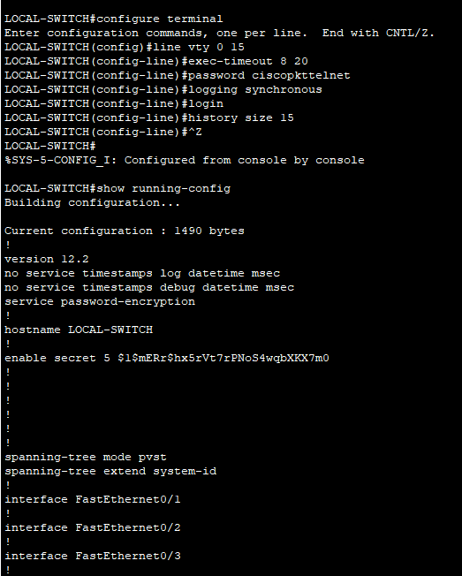

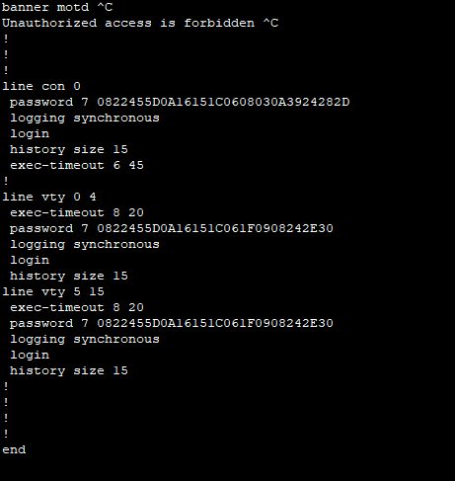

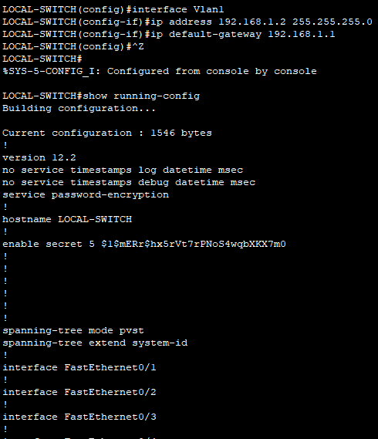

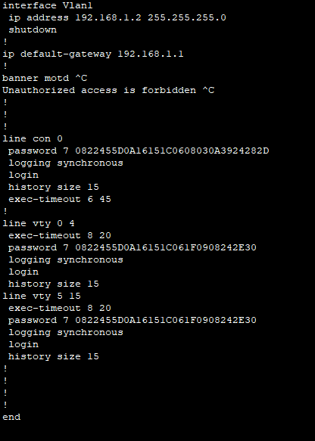

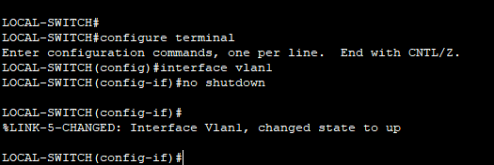

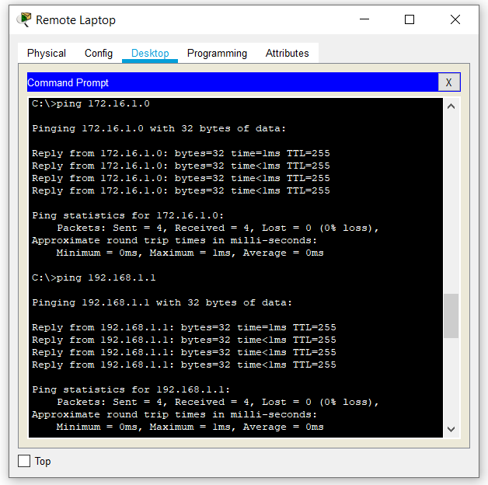

**Test telnet connectivity from the Remote Laptop using the telnet client.**

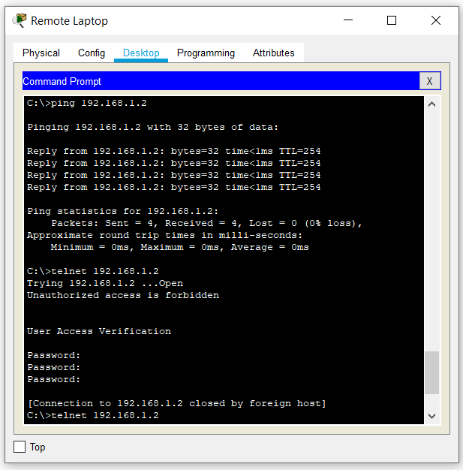

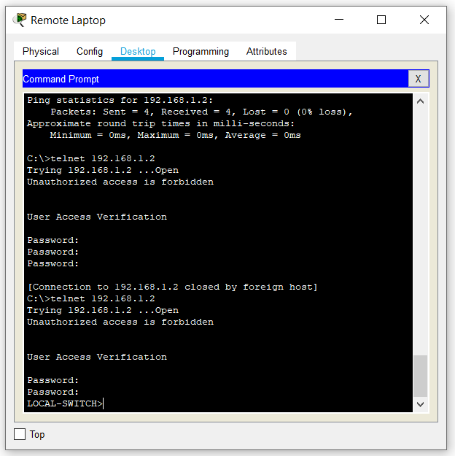

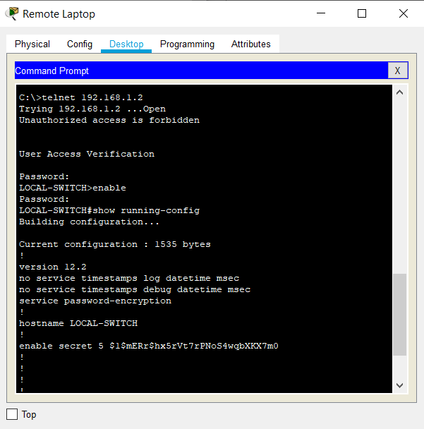

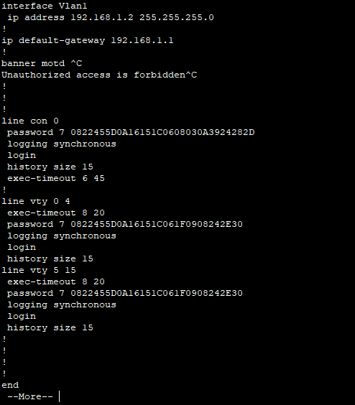

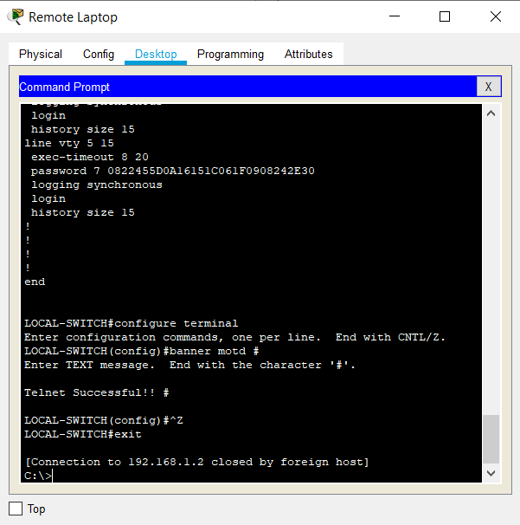

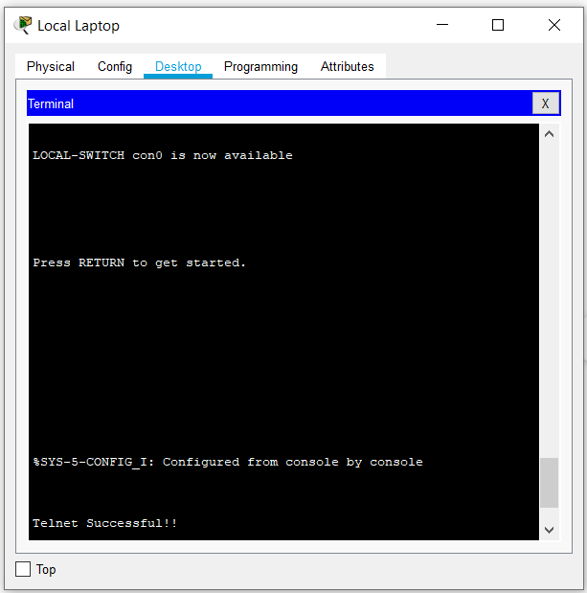

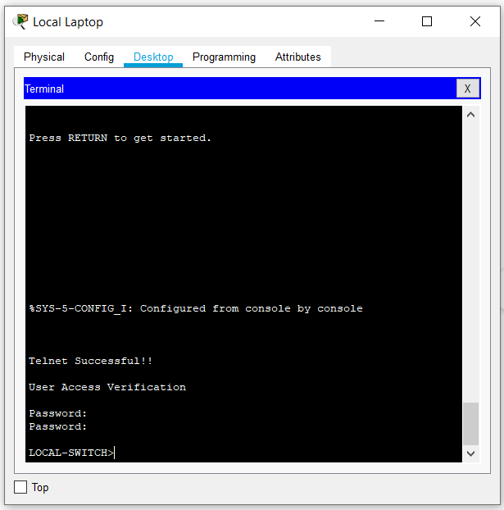

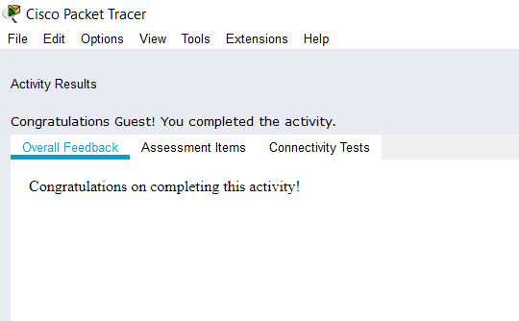

**Conclusion:**

Thus, I came to know how to setup a network, testing connection from one PC to another, and the implementation of a prototype of network and successfully configured basic settings of router and switch like hostname, password etc.